**Boston Ivy Tech – Bus Fees**

**Customer Access Key - df18ee0f-8d9a-45aa-a29e-d487c21de374**

**Customer ID – 1463**

**Transaction ID - 18397**

**Custom Fields and Character Length -**

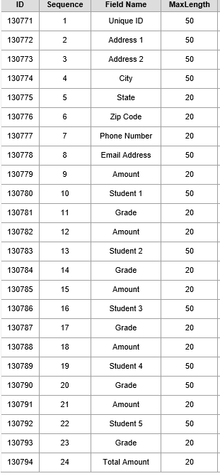

**Account Number to use for Testing**

**Routing number: 122105278 Valid Account Number: 0000000018**

Link to be inserted for form action: <https://paymentsuat.unibank.com/remotetransaction/RTI.aspx>

<?xml version='1.0' encoding='UTF-8' ?>

<!DOCTYPE cXML SYSTEM 'http://xml.cxml.org/schemas/cXML/1.2.014/cXML.dtd'>

<cXML xml:lang='en-us'>

<cart>

<transaction lineNum='1' txID='18397'>

<qty>1</qty>

<amount>84.29</amount>

<accessKey>df18ee0f-8d9a-45aa-a29e-d487c21de374</accessKey>

<customerID>1463</customerID>

<C130771>Provide Data</C130771>

<C130772>Provide Data</C130772>

<C130773>Provide Data</C130773>

<C130774>Provide Data</C130774>

<C130775>Provide Data</C130775>

<C130776>Provide Data</C130776>

<C130777>Provide Data</C130777>

<C130778>Provide Data</C130778>

<C130779>Provide Data</C130779>

<C130780>Provide Data</C130780>

<C130781>Provide Data</C130781>

<C130782>Provide Data</C130782>

<C130783>Provide Data</C130783>

<C130784>Provide Data</C130784>

<C130785>Provide Data</C130785>

<C130786>Provide Data</C130786>

<C130787>Provide Data</C130787>

<C130788>Provide Data</C130788>

<C130789>Provide Data</C130789>

<C130790>Provide Data</C130790>

<C130791>Provide Data</C130791>

<C130792>Provide Data</C130792>

<C130793>Provide Data</C130793>

<C130794>Provide Data</C130794>

<postBackURL></postBackURL>

<allowModify>1</allowModify>

</transaction>

<returnURL>http://www.google.com</returnURL>

<returnButtonText>Return Text</returnButtonText>

<showCancelButton>true</showCancelButton>

<cancelButtonURL>http://www.google.com</cancelButtonURL>

<cancelButtonText>Cancel Text</cancelButtonText>

<forceTimeoutTimeFrame>0</forceTimeoutTimeFrame>

<forceTimeoutRedirectURL>http://www.google.com</forceTimeoutRedirectURL>

</cart>

</cXML>